April 2022
Immaculate Conception Parish
Sunday | Monday | Tuesday | Wednesday | Thursday | Friday | Saturday
 |  |  |  |  | 1 | 2
 |  |  |  |  |  | Mass at 4:00 PM
3 | 4 | 5 | 6 | 7 | 8 | 9
5th Sunday of Lent  Mass at 11:00 AM |  |  |  | Meeting for  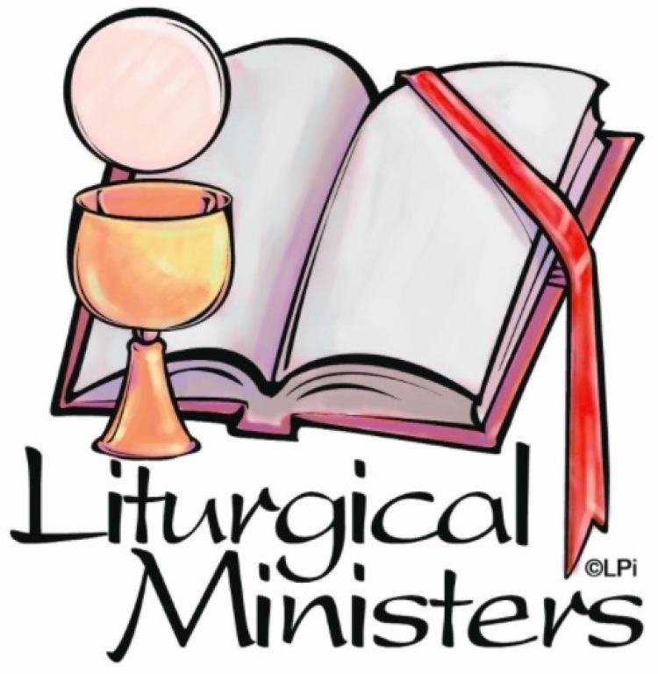  all Lectors  and Ministers  at 6:30 PM in  the Church |  | Mass at 4:00 PM
10 | 11 | 12 | 13 | 14 | 15 | 16
Palm Sunday  Masses at  7:30 AM  and 11:00 AM | 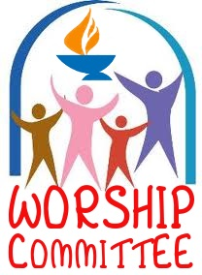  Word/Worship Meeting at  7:30 PM |  | Pastoral Council  Meeting at  6:00 PM | 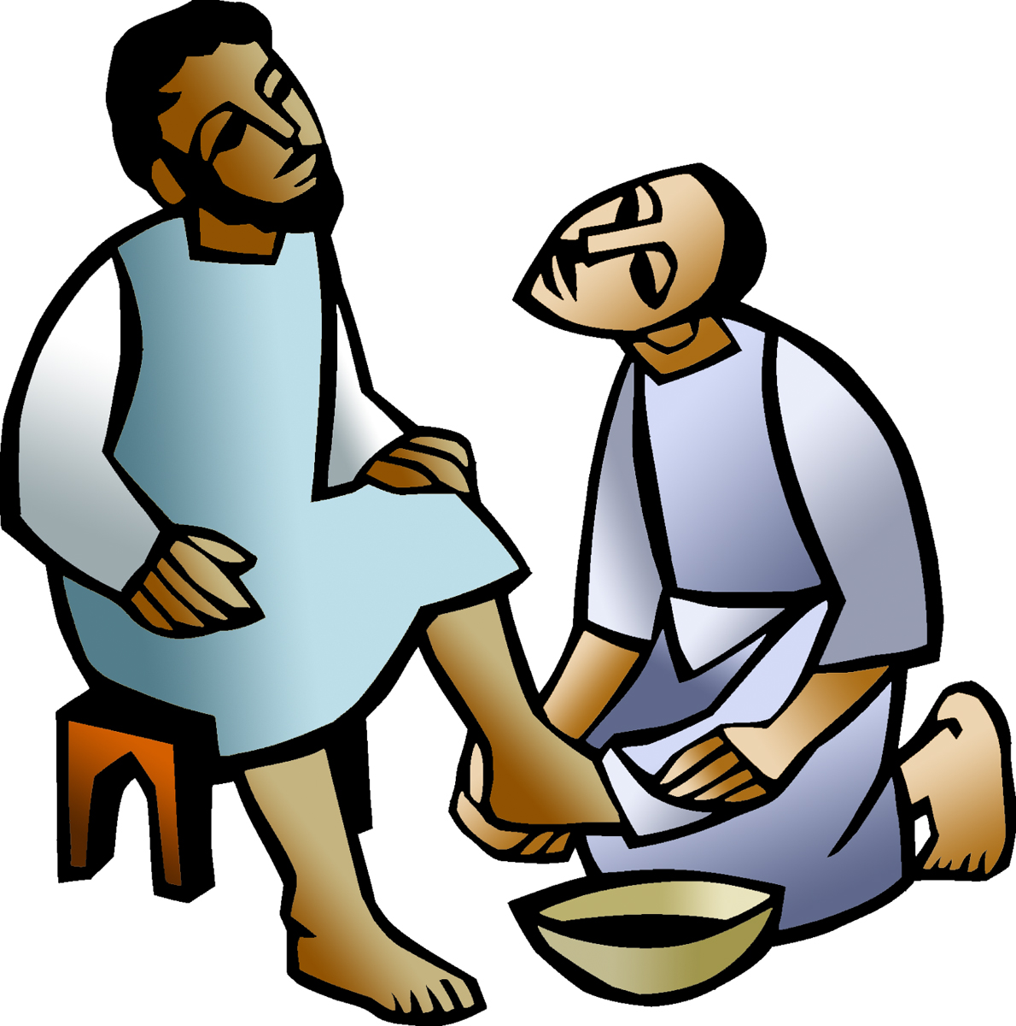  Holy Thursday Mass at  7:00 PM | Good Friday Service at  1:00 PM | 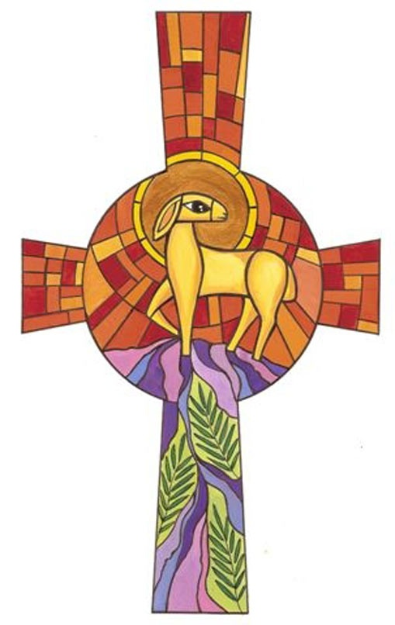  Easter Vigil  Mass at  8:00 PM
17 | 18 | 19 | 20 | 21 | 22 | 23
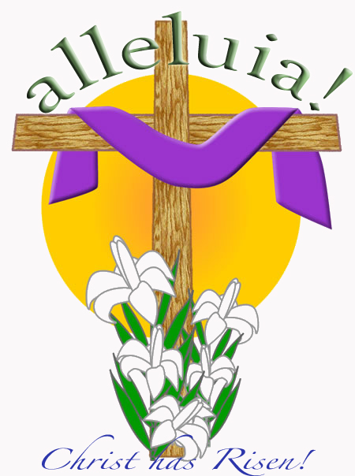  Easter Sunday Masses at  7:30 AM and  11:00 AM |  |  | Community/Service  Meeting at 6 PM  In the Church |  |  | Mass at 4:00 PM
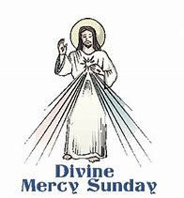  24 | 25 | 26 | 27 | 28 | 29 | 30
Divine Mercy Sunday  Mass at  11:00 AM |  |  |  |  |  | Mass at 4:00 PM
*** REMINDER: FORGET-ME-NOT BAGS ARE DUE ON THE ALTAR OR IN THE PARISH OFFICE BY APRIL 3RD.

