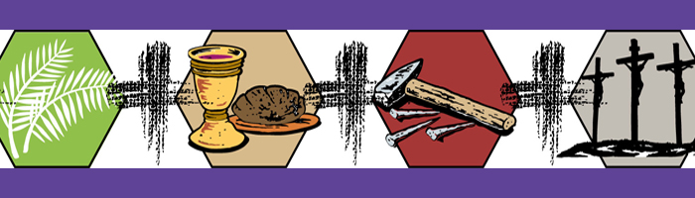

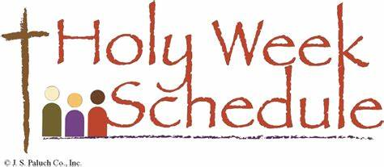

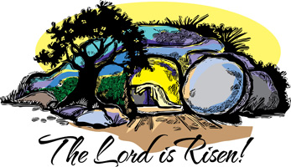
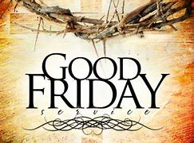
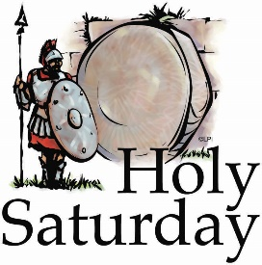
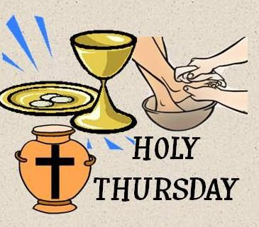

PALM SUNDAY MASSES, MARCH23RD AND 24TH
IMMACULATE CONCEPTION 4:00 PM; 7:30 AND 11:00 AM
GOOD SHEPHERD 6:00 PM; 8:00 AM AND 9:30 AM
ST. PATRICK’S 5:00 PM; 10:15 AM
HOLY THURSDAY MASSES, MARCH 28TH
IMMACULATE CONCEPTION 7:00 PM
GOOD SHEPHEHRD 7:00 PM
ST. PATRICK’S 7:00 PM
GOOD FRIDAY SERVICE, MARCH 29TH
IMMACULATE CONCEPTION 1:00 PM
GOOD SHEPHERD 1:00 PM
ST. PATRICK’S 2:00 PM
EASTER VIGIL, SATURDAY, MARCH 30TH
IMMACULATE CONCEPTION 8:00 PM
GOOD SHEPHERD 8:00 PM
ST. PATRICK’S 8:00 PM
EASTER SUNDAY, MARCH 31ST
IMMACULATE CONCEPTION 7:30 AND 11:00 AM
GOOD SHEPHERD 8:00 AND 9:30 AM
ST. PATRICK’S 10:15 AM

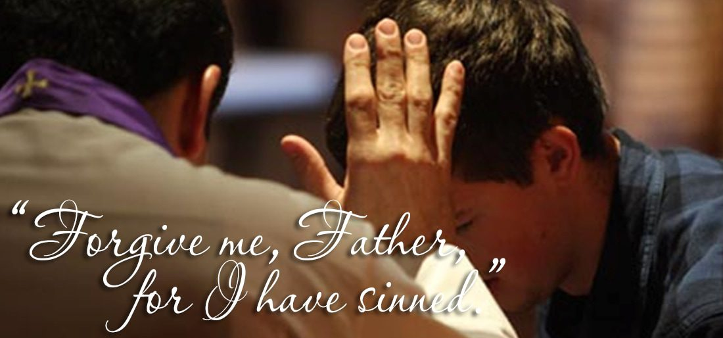

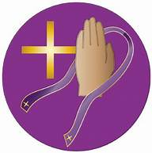
IMMACULATE CONCEPTION
Monday evenings 6:00 – 6:50 PM;
Tuesday through Friday 6:15 – 6:50 AM;
Saturday 3:00 – 3:30 PM
GOOD SHEPHERD
Monday 7:00 AM – 7:50 AM
Wednesday 6:00 PM – 6:50 PM
Saturday 5:00 – 5:30 PM
ST. PATRICK
Saturday 4:00 – 4:45 PM
Sunday 9:00 – 9:45 AM

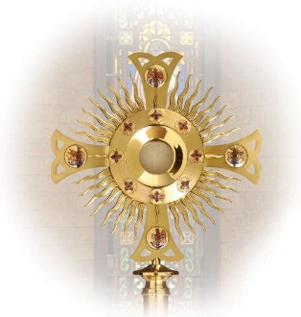
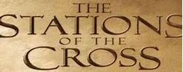
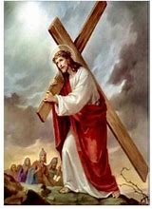
IMMACULATE CONCEPTION PARISH:
Stations of the Cross Fridays at Noon
Exposition of the Blessed Sacrament
and Benediction from 6:00 to 6:55 PM
and Stations of the Cross at 7:00 PM
GOOD SHEPHERD PARISH:
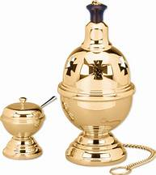
Exposition of the Blessed Sacrament
and Benediction from 3:00 to 3:55 PM
and Stations of the Cross at 4:00 PM
ST. PATRICK’S PARISH:
Fridays at 6:00 PM

