IMPORTANT ADVENT AND CHRISTMAS SEASON INFORMATION

SACRAMENT OF RECONCILIATION SCHEDULE:
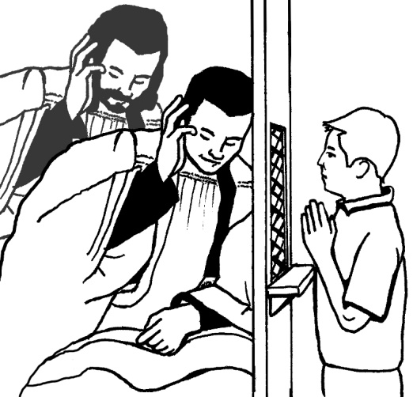
IMMACULATE CONCEPTION PARISH:
Monday evenings before the 7:00 PM mass from 6:00 – 6:50 PM;
Every Tuesday through Friday mornings from 6:00 – 6:50 AM;
Saturday afternoons from 3:00 – 3:30 PM.

GOOD SHEPHERD PARISH:
Monday mornings from 7:00 AM – 7:50 AM;
Wednesday evening 6:00 PM – 7:00 PM
Saturday afternoons from 5:00 – 5:30 PM.

Father will hear confessions in his office at Good Shepherd Parish.

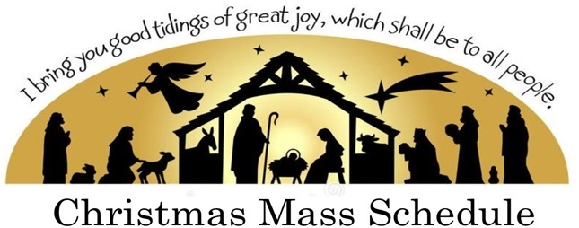

IMMACULATE CONCEPTION PARISH

Christmas Eve Mass, Thursday, December 24th at 2:00 PM, 4:00 PM
and 10:00 PM
Christmas Day Mass, Friday, December 25th at 7:30 AM and 11:00 AM
New Year’s Eve Mass, Thursday, December 31st at 4:00 PM
New Year’s Day Mass, Friday, January 1st at 11:00 AM

GOOD SHEPHERD PARISH

*** All Christmas and New Year’s Masses Will Be Available
on Your FM Radio in the Lower Parking Lot at Good Shepherd Church ***

Christmas Eve Mass, Thursday, December 24th at 2:00 PM, 4:00 PM
and 9:00 PM
Christmas Day Mass, Friday, December 25th at 8:00 AM and 9:30 AM
New Year’s Eve Mass, Thursday, December 31st at 6:00 PM
New Year’s Day Mass, Friday, January 1st at 8:00 AM and 9:30 AM

