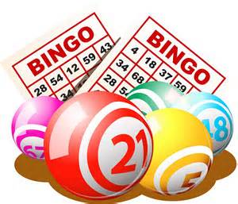**HAM BINGO**

at Immaculate Conception

Parish Center

Sunday, April 7th.

Kitchen opens

at 11:30 AM.

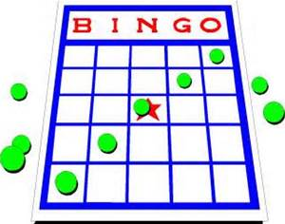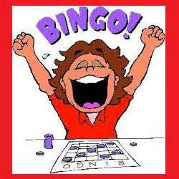Early Birds start

at 12:30 PM

******Regular Bingo starts

at 1:00 PM.

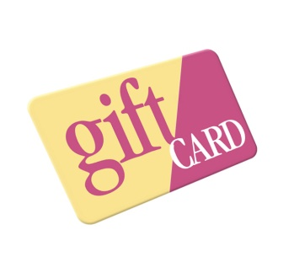Carone’s Sure-Save

Gift Card Per Game