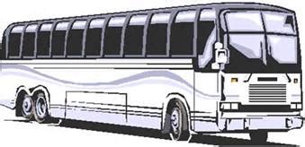
PARISH BUS TRIP to
Hunterdon Hills Playhouse on Wednesday, April 24th, to see “Take
Me Away.” Cost is $83.00. Call Mary Lloyd at 570-578-6720 to make reservations. Deadline is April 3rd.

